EXPERIMENT NO. 12
Create User-Defined Packages and Use Wrapper Classes

Roll No.: C-60
Name: Avdhut Parish Madhavi
Class / Division: SE-C
Batch: C2
Date of Experiment: ____________________________________________
Date of Submission: ____________________________________________
Grade: ____________________________________________

B.1 Document Created by the Student
Create one additional class in the same package and import it into a second application:

An additional class named PatientDetails is created in the same healthcare package. It stores and displays the patient's name and age. The PatientDetails class is imported into the separate PackageDemo application along with PatientCode. The program also demonstrates Integer and Double wrapper classes, autoboxing, and unboxing.

B.2 Student Program / Output
Paste/write the final program and attach or reproduce the observed output below:

File 1: healthcare/PatientCode.java
package healthcare;
public class PatientCode {
private int id;
public PatientCode(int id) {
this.id = id;
}
public void display() {
System.out.println("Patient code: " + id);
}
}
File 2: healthcare/PatientDetails.java
package healthcare;
public class PatientDetails {
private String name;
private int age;
public PatientDetails(String name, int age) {
this.name = name;
this.age = age;
}
public void displayDetails() {
System.out.println("Patient name: " + name);
System.out.println("Patient age: " + age);
}
}
File 3: PackageDemo.java
import healthcare.PatientCode;
import healthcare.PatientDetails;
public class PackageDemo {
public static void main(String[] args) {
PatientCode p = new PatientCode(101);
p.display();
PatientDetails details = new PatientDetails("Meera", 25);
details.displayDetails();
Integer boxed = 25; // autoboxing
int unboxed = boxed; // unboxing
Double value = 62.5;
System.out.println("Integer object: " + boxed);
System.out.println("Unboxed value: " + unboxed);
System.out.println("Double object: " + value);
}
}

Output:

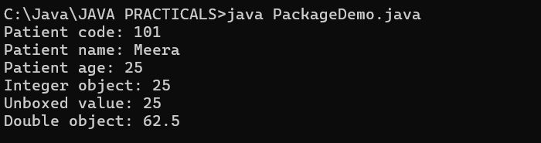

B.3 Observations and Learning
• Why are packages useful?
Packages are useful because they group related classes, organize programs, avoid naming conflicts, and make code easier to maintain and reuse.

• What is autoboxing?
Autoboxing is the automatic conversion of a primitive value into its corresponding wrapper-class object. For example, Integer boxed = 25; converts int value 25 into an Integer object.

• What is the difference between a primitive int and an Integer object?
int is a primitive data type that stores an integer value directly. Integer is a wrapper class that represents an int value as an object and can be used where objects are required.

Student observation / learning:
I learned how to create a user-defined package and import its classes into another application. I also learned that wrapper classes represent primitive values as objects, autoboxing converts a primitive into a wrapper object, and unboxing converts a wrapper object into a primitive value.

B.4 Conclusion
Modular healthcare software architecture is a stated course context.

Student conclusion:
The experiment successfully demonstrates the creation and use of a user-defined healthcare package. The additional PatientDetails class is imported into the main application, and Integer and Double wrapper classes are used to demonstrate autoboxing and unboxing.

B.5 Questions of Curiosity
1. Why are packages useful?
Packages group related classes, improve program organization, help avoid naming conflicts, and support code reuse and maintenance.

2. What is autoboxing?
Autoboxing is the automatic conversion of a primitive value into its corresponding wrapper object, such as int to Integer.

3. What is the difference between int and Integer?
int is a primitive data type, whereas Integer is a wrapper class that stores an int value as an object. Integer can also be null, while a primitive int cannot.

